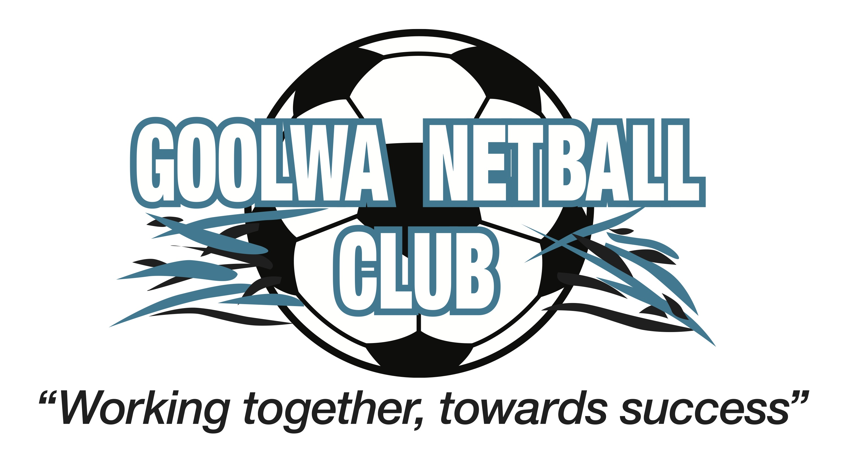

Anti Harrassment and Bullying
The GNC has a commitment to ensure that all members of our club feel safe and included during time with the club. All club members should be treated with dignity and respect.

Our The GNC opposes all forms of harassment, discrimination and bullying. This includes treating or proposing to treat someone less favourably because of a particular characteristic; imposing or intending to impose an unreasonable requirement, condition or practice which has an unequal or disproportionate effect on people with a particular characteristic; or any behaviour that is offensive, abusive, belittling, intimidating or threatening – whether this is face-to-face, indirectly or via communication technologies such as mobile phone and computers. Some forms of harassment, discrimination and bullying are against the law and are based on particular characteristics such as age, disability, gender, sexual orientation, pregnancy, political or religious beliefs, race, and marital status.

Our club takes all claims of harassment, discrimination, bullying and cyber bullying seriously.

We encourage anyone who believes they have been harassed, discriminated against or bullied to raise the issue with the club.

GNC has supplied this club policy to local schools to ensure that issues that arise during netball training, games, team selection or other club activities are not used as topics of content for bullying while at school.
Examples of Bullying
- Teasing and being made fun of
- Spreading rumours, verbally or via social media
- Sending unwanted messages,
- Defamation
- Deliberate exclusion in order to hurt
- Offensive gestures or sounds
- Sniggering, rolling of eyes, whispering

Involvement: means active harassment, being present and passively supportive when harassment by others is taking place.
Behaviour becomes harassment when the person has indicated that it is unwelcome or wanted and it does not stop immediately.
Please note that GNC considers all bullying that occurs during club time as a serious issue whether it is related to netball or not. When players step onto court they are expected to leave outside grievances with individuals off the court. Where the content of the bullying is related to netball, GNC will take action regardless of where the bullying took place, ie school, social media, mobile phone.

Actions
It is your right not to be harassed or bullied. A safe place is a caring place and people at the club care and can help you.
If you are Harassed/Bullied
- Tell the person who is harassing you that you find the behaviour unacceptable and to stop
- Talk with a friend, your coach, your parent, the age appropriate coordinator or advocate or the child safety officer.
If you witness Harassment or Bullying
- Acknowledge that it is occurring, don’t ignore it just because you are not involved
- Talk to the person who is behaving inappropriately and ask them to stop
- Report the issue to your coach, player advocate, child safety officer.

GNC Actions
The aim of the club is to restore good relationships to promote happy and successful teams and an environment where everyone can enjoy sport.
The GNC will:
- Recognise the issue
- Deal with reports of bullying or harassment through a range of actions. Depending on the seriousness of the offence and the impact on the victim these could include any one or combination of the following.
- Discussion/education/warning
- Mediation
- Discussion with parents
- Suspension
- Exclusion
These expectations of behaviour are set out in the GNC Code of Behaviour. The basis of these is to treat people how you would expect to be treated and contribute to a happy, safe, friendly and encouraging club environment.

Further Action
Club Members who continue to engage in behaviour that is in breach of this policy may be subject to disciplinary measures as outlined in our Member Protection Policy. This action may result in termination or suspension from current and future membership and or referral to Leagal entities.

